CLEAN COASTS GRANT APPLICATION FORM 2018
Please read Clean Coasts Grant Information Document before completing this form.

Clean Coasts Group Name: ________________________________________________________

Contact Name: _________________________________________________________________

Position in group: _______________________________________________________________

Address: _______________________________________________________________________

______________________________________________________________________________

Contact Tel No: _____________________Alternative Tel No: ___________________________

Email: _________________________________________________________________________

Location of Group: ______________________________________________________________

Adopted Beach: _________________________________________________________________

Approximate number of volunteers: _______________________________________________

Please briefly describe your group and your proposed activities for 2018, including benefits resulting from the grant money, beach cleaning kit or beach signage.

Grant requested
Please tick the box for the grant you are applying for. (Please tick the appropriate box below).
- □ Grant up to €500
Please list item(s) that your Clean Coasts Group request through An Taisce’s Clean Coasts Grant scheme. (Please note. Item(s) need to have written quotation(s) submitted with this application, see Clean Coasts Grant Information)
___________________________________________________________________________________________________________________________________________________________________________________________________________________________________________________________________________________________________________________________________________________________________________________________________________________________________________________________________________________________________________________________________________________________________________________________TOTAL GRANT REQUESTED_______________________________
- □ Beach Cleaning Kit (Please indicate the number of each item your group would require)

Litter pickers __________ High-vis bibs____________ Gloves __________ Rolls of Bags_____

- □ Beach Sign for display at your adopted beach, with the aim of making beach users aware of your Clean Coasts efforts. (Please see example sign below)

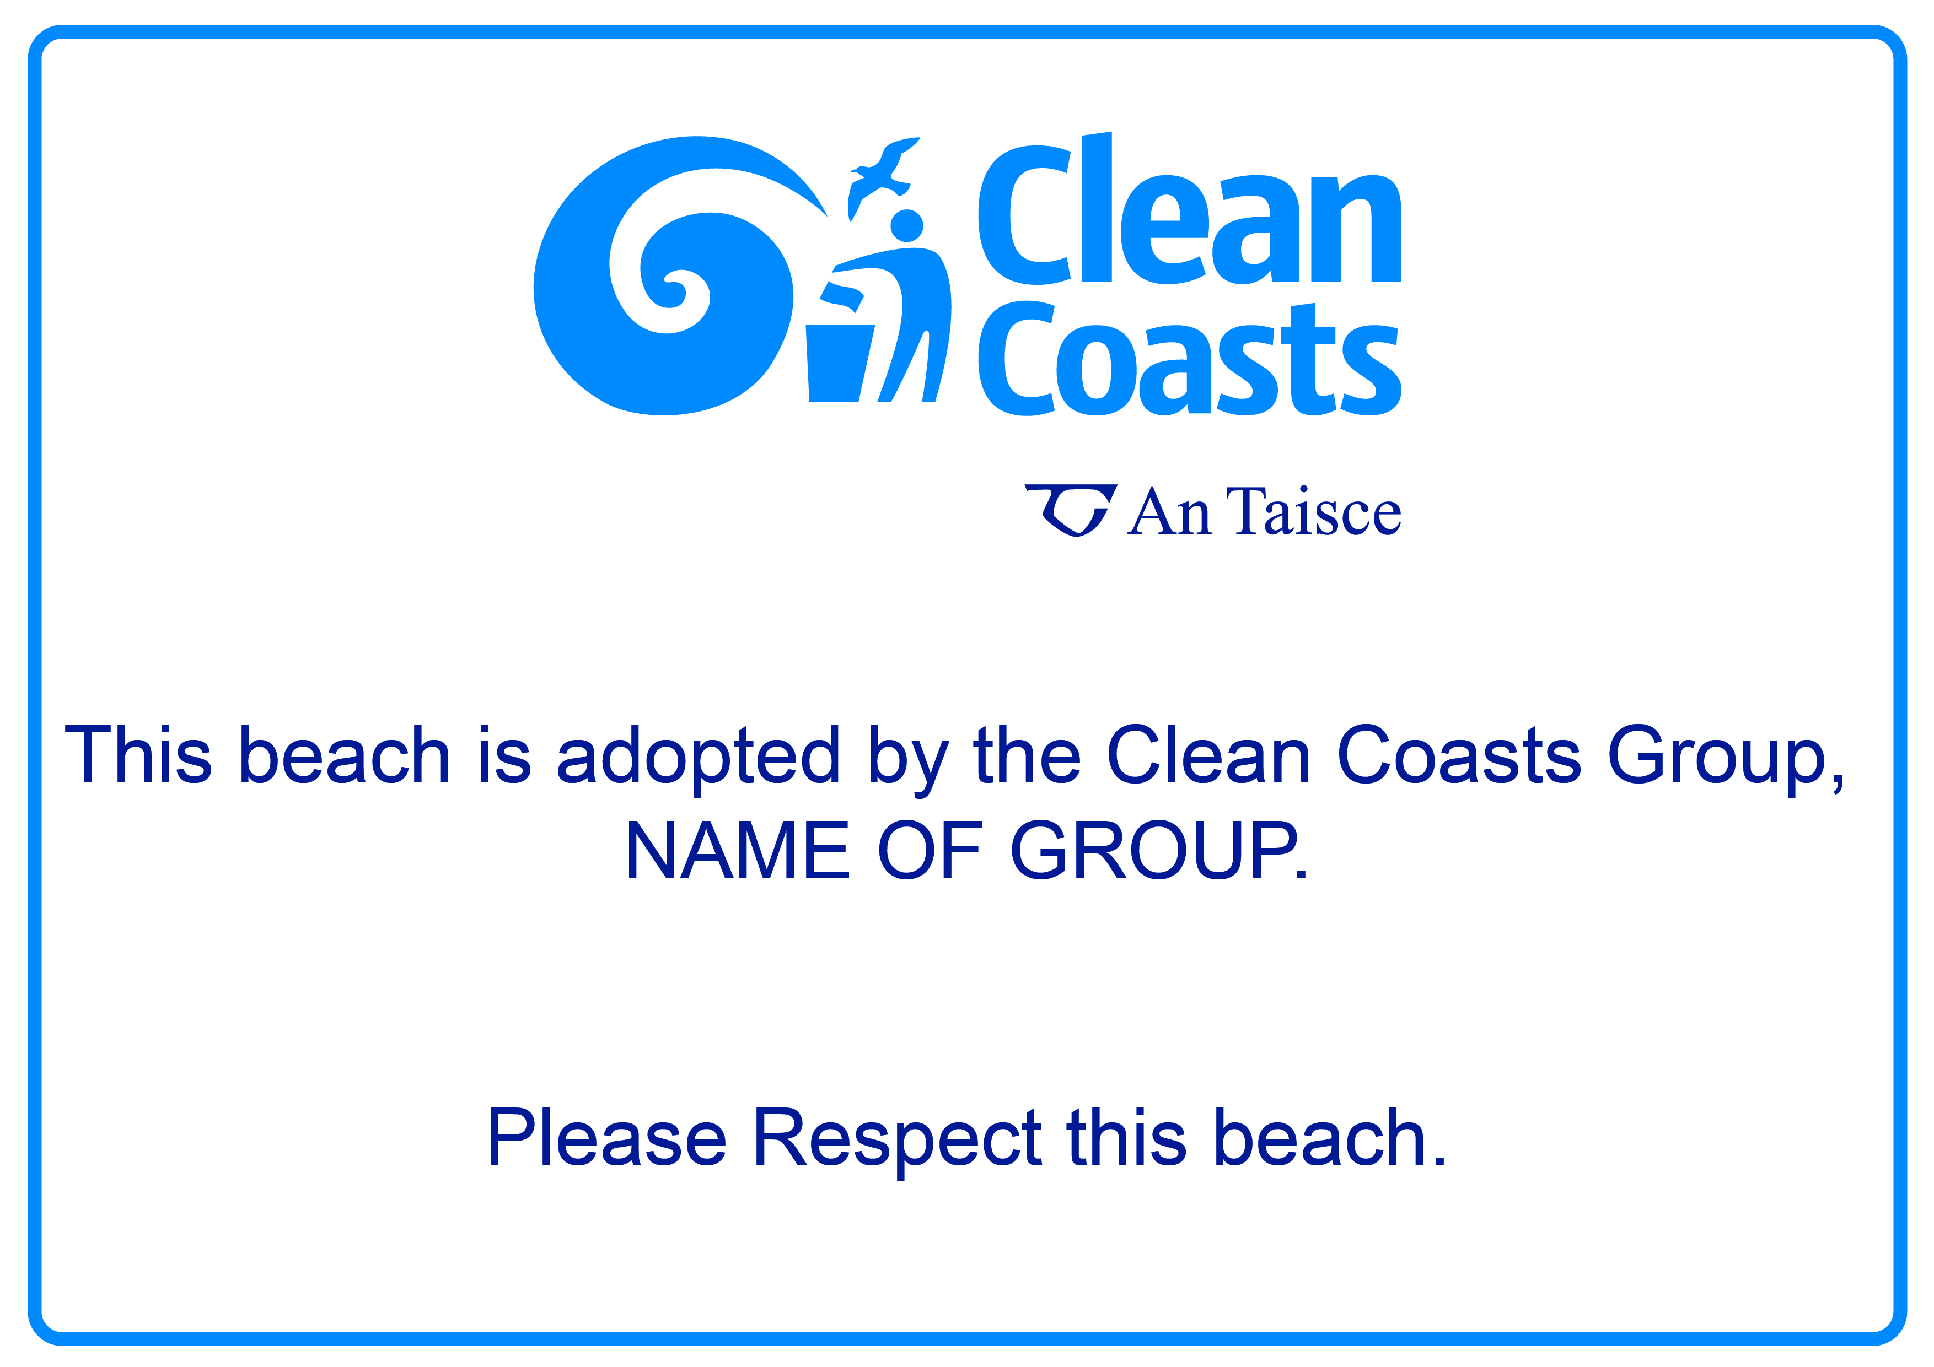

Data Protection
The information given will be entered and processed on computer. The forms will also be kept. The information will be used by An Taisce’s Clean Coasts for administration purposes of the grant scheme and for the monitoring and promotion of the programme.

I agree to the above use of my data and I confirm that to the best of my knowledge and belief, all replies given on this application form are true and accurate.

Signed by the contact person: ________________________________________
Position in group: ___________________________________________________
Please print name: __________________________________________________
Date: _____________________________________________________________
Account Details for Clean Coasts Group
Account Name: _____________________________________________________
Account Number: ___________________________________________________
Account Sort Code: __________________________________________________
IBAN Number: ______________________________________________________

