

Article from Transition Kerry

Date: 17/10/2017

\*\*\*\*\*\*\*\*\*\*\*\*\*\*\*\*\*\*\*\*\*\*\*\*\*\*

**UP FOR THE CHALLENGE? - Community Solutions to Climate Change -**

**Saturday November 11th 2017**

**Manor West Hotel, Tralee**

**9.30 – 4pm.**

**Ten years ago Transition Kerry asked the question ‘What will Tralee look like in the year 2030’,** because we recognised that *‘climate change changes everything’.* Now, we have planned this public gathering to mark ten years of working on this transition in Kerry and to strengthen **Community Solutions for Climate Change.**

**What kind of future do we want to create for Kerry?**

**How do we create community solutions to the challenges of climate change?**

On the day, speakers and participants will address how communities can respond and become more resilient in the face of the increasing challenges of climate change.  We will look at national policy and mitigation, food security & biodiversity loss, sustainable energy and co-operatives.  We will be discussing how we can work in partnership with community groups and government structures; encouraging personal participation and actions.

**We will have a range of speakers on climate change and community resilience including experts;**  
***John Gibbons (Journalist)******Dr. Cara Augustenborg (Lecturer in Climate and Environment, UCD)******Dr. Margaret Desmond (Environmental Research Institute – ERI, UCC)***

We are going to have a number of online interviews:  
***Professor John Sweeney  (IPCC Climatologist)******Rob Hopkins (Founder of the Transition movement in Kinsale over 12 years ago)***

There will be input from Transition Kerry on our 3-year plan, Kerry Sustainable Energy Co-operative (KSEC) on their work and from representatives who are involved in sustainable local community projects.

*We will be highlighting the OPW CFRAM Flood maps on the day. These show the projected extent and expected depths of predicted flooding from inland and sea in Kerry and their potential consequences. The Local Community Water Officer, Bláithín Ní Ainín will be there on the day with display explaining water catchments and their management maps of Kerry’s river catchments, displaying the current ecological status of Kerry’s rivers, lakes, estuaries and groundwater.*

**We are hosting this event with** Davie Philips from Cultivate and with support from our key statutory partners, including Kerry County Council, the EPA and Kerry Sustainable Energy Co-op. This event is also being supported by Kerry Public Participation Network (Kerry PPN) and Siamsa Tíre.  We are planning for a strong local community representation on the day, which will be complemented by key local and national stakeholders.

**Transition Kerry has been active for 10 years**, organising public events, delivering educational programmes and initiating workshops on best environmental practice and up-skilling for community resilience. This event aims to inform and shape our ongoing climate action work here in Kerry and to strengthen local networks, through our key international, national and local speakers.

**Registration:**  
Registration is essential. There is a €10 contribution to the event, but concessions are available.   Please contact us directly if you need further information or want to volunteer - Niamh Ní Dhúill @ 086 7247066 – [info@transitionkerry.org](mailto:info@transitionkerry.org).

**REGISTER HERE:**

<https://www.iregister.ie/v2/events/transition-kerry/>

**Lunch:**  
Lunch is available and catered directly by the Manor West Hotel. We will forward more information closer to the date.

Sinne le meas

The Transition Kerry Team

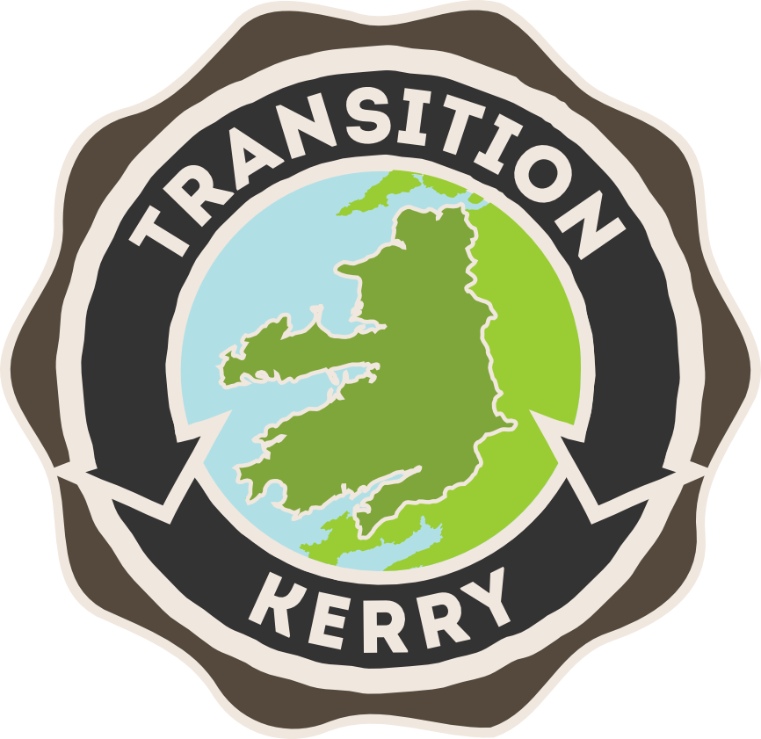 Macintosh HD:Users:niamhnidhuill:Desktop:epa logo copy.pdf 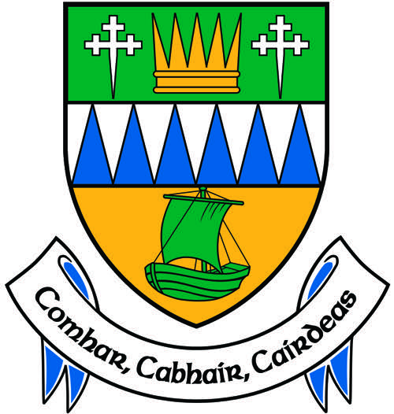 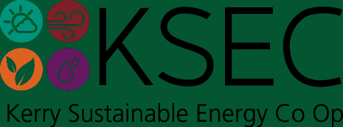

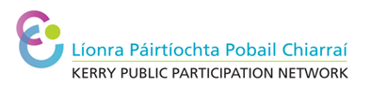  Macintosh HD:Users:niamhnidhuill:Desktop:Siamsa_Tire_Colours logo copy 2.pdf 